Practical No. 7

Screen Scraping and Web Scraping methods

# Automate the following screen scraping method using UiPath:

* 1. **Full Text Steps:**
     1. Use Open Browser to navigate to Amazon Electronics page.
     2. Add Get Text activity and indicate the element (“Electronics”).
     3. Save the output to a variable (scrapdata).
     4. Use Message Box to display scrapdata.ToString.

# Output:

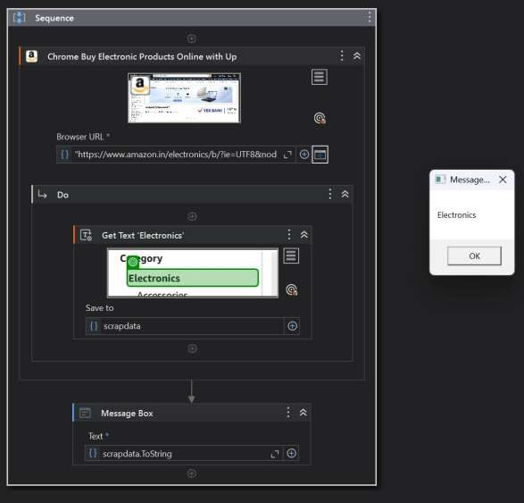

# Demonstrate Data Scraping and display values in Message box using OCR.

**Steps:**

* 1. Open UiPath Studio and create a new process.
  2. Drag and drop the Use Application/Browser activity and select Chrome browser.
  3. In the Browser URL property, enter chrome://newtab/.
  4. Inside the Do container, add a Get OCR Text activity.
  5. Indicate the target area in the Chrome window where you want to scrape text.
  6. Select Tesseract OCR Engine as the OCR method.

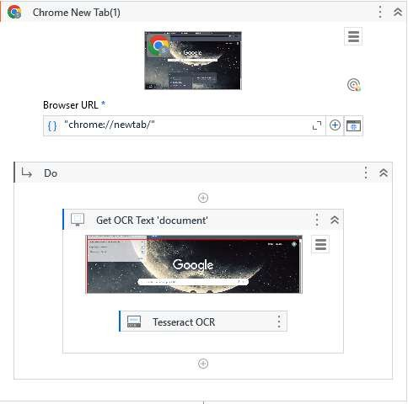

* 1. Create a variable (e.g., variable1) to store the extracted text output.

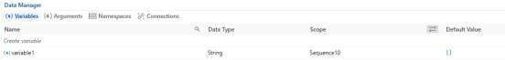

* 1. After the OCR activity, add a Message Box activity.
  2. In the Text property of the Message Box, pass the variable name with .ToString.

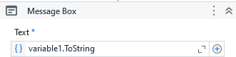

* 1. Run the workflow → it will scrape text from the browser and display it in the message box.

# Output:

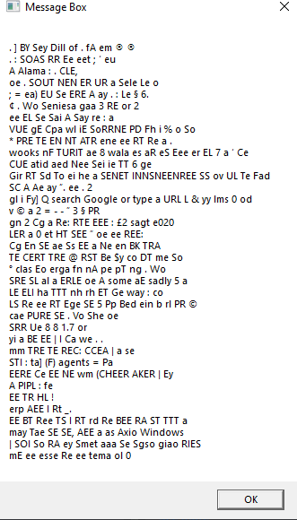

**Conclusion:** Thus we have studied to demonstrate Data Scraping Using OCR in UiPath.